**Experiment No. 14**

**Experiment Name: Implementation of FCFS disk scheduling algorithm .**

**Objectives:**

* What is FCFS disk scheduling algorithm ..
* How to implementation this algorithm

**Source Code:**

|  |
| --- |
| #include<bits/stdc++.h>  using namespace std;  int main()  {  int a,b,c=0,i=1;  char ch='y';  cout<<"enter value of initial head position : ";  cin>>a;  do  {  cout<<"enter value of cylinder : "<<i<<" : ";  cin>>b;  c+=abs(a-b);  a=b;  i++;  cout<<"\nWant to enter more(y/n):";  cin>>ch ;  }while(ch!='n');  cout<<" \nTotal head movement = "<<c<<" cylinders";  } |

**Output:**

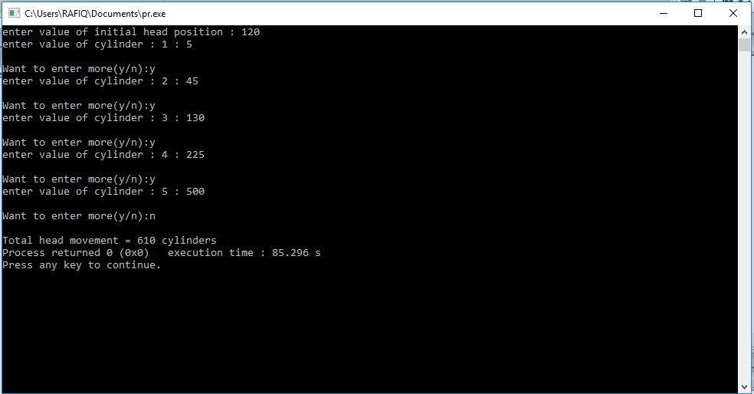

**Conclusion:** In operating systems, seek time is very important. Since all device requests are linked in queues, the seek time is increased causing the system to slow down. Disk Scheduling Algorithms are used to reduce the total seek time of any request.